Section One – Research Methods (20 marks)
Question One
Researchers wanted to investigate the ongoing health effects of working as a medical student at a busy city hospital. Participants were first year medical students chosen from a hospital close to the university where the researchers worked. They were followed throughout their medical training. Researchers met participants once a year over an eight-year period.
- Name the study design used by researchers. Circle the correct answer below. (1 mark)

Longitudinal / Cross-sectional

- State one advantage of using this type of study design. (1 mark)

__________________________________________________________________________________________________________________________________________

- State one disadvantage of using this type of study design. (1 mark)

__________________________________________________________________________________________________________________________________________

- Identify the sampling technique used in this study. Justify your answer. (1 mark)

________________________________________________________________________________________________________________________________________
- State one disadvantage of this type of sampling. (1 mark)

__________________________________________________________________________________________________________________________________________

- Provide ONE example of quantitative data and one example of qualitative data that psychologists could use to assess the health effects of working as a medical student. State whether each example is objective or subjective. (4 marks)
__________________________________________________________________________________________________________________________________________
__________________________________________________________________________________________________________________________________________
Question Two
Read an abstract and interpret and develop an experiment: hypothesis and steps to ensure a reliable and valid method
Abstract one
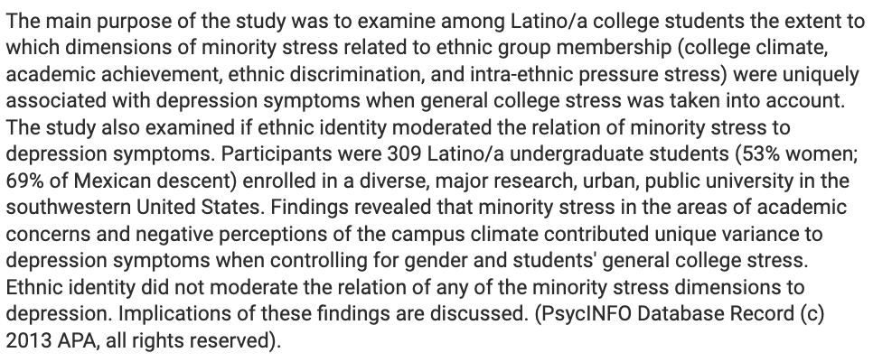
Abstract two
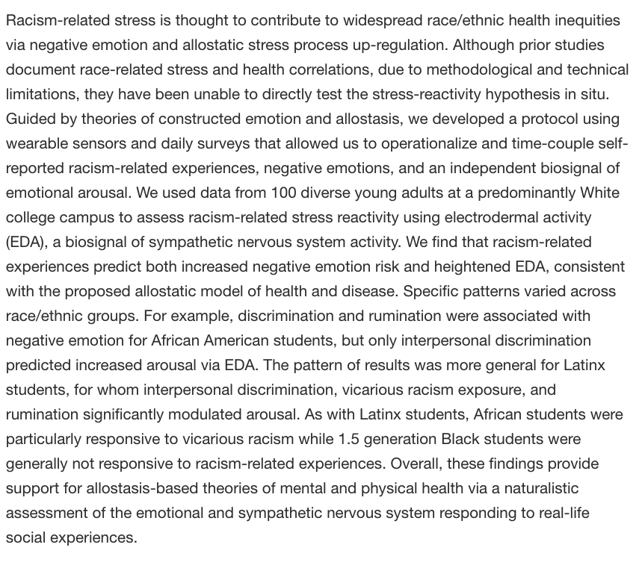
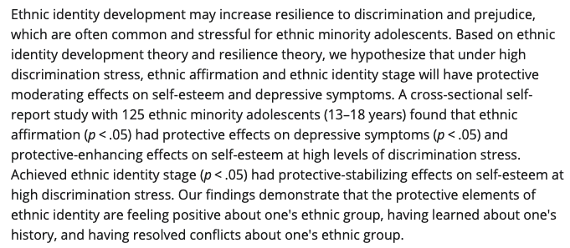

Short Answer Questions– Developmental Psychology (18 marks)

- Piaget identified four stages in a human’s cognitive development. Name and describe the two stages below: (4 marks)

Piaget’s first stage of cognitive development:

Name: ___________________________________________________________________

Description: __________________________________________________________________________________________________________________________________________________

Piaget’s third stage of cognitive development:

Name: ___________________________________________________________________

Description: __________________________________________________________________________________________________________________________________________________

Dana is playing hide and seek with her brother Dion (age three). Dion stands in the centre of the room and covers his eyes with his hands and says, ‘I am hiding’.
- Explain, why Dion believes that he is hiding, referring to the relevant concept from Piaget’s theory of cognitive development. (2 marks) ____________________________________________________________________________________________________________________________________________________________________________________________________________________________________________________________________________

- Outline two skills that children develop as part of their social and emotional development. (2 marks)
____________________________________________________________________________________________________________________________________________________________________________________________________________________________________________________________________________

Table 2: Concordance rates of a given trait in Monozygotic and Dizygotic twins
Trait | Monozygotic Twins | Dizygotic Twins
IQ | 74 | 58
Anxiety Disorder | 45 | 25
Major Depression | 54 | 20

- According to Table 2, which trait has a largest genetic component? Use information in the table to justify your answer. (2 marks)
____________________________________________________________________________________________________________________________________________________________________________________________________________________________________________________________________________

- Explain why twin studies and adoption studies are useful for the Nature vs Nurture debate. (4 marks)
____________________________________________________________________________________________________________________________________________________________________________________________________________________________________________________________________________
____________________________________________________________________________________________________________________________________________________________________________________________________________________________________________________________________________

